REWARD
Bobby Bird
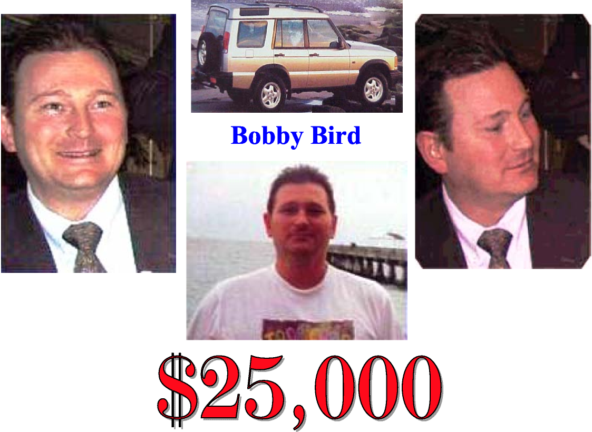
On the evening of May 22, 2001, just before Bobby's murder, he was seen being driven by an unknown person in his gold, Land Rover SUV on West Main and at the BP Gas Station on the Asheville Highway.
$1,000 will be given for any verifiable information
about any person Bobby was with on the night of
May 22, 2001

$25,000 will be given for direct information
which leads to the arrest and conviction of Bobby’s killer

CALL CONFIDENTIAL TO FAMILY AT (615) 300-6762

